Name: Mohamed Ahmed Abdul hafiz Abdul aati Amer

B.N: 648

Topic: artificial intelligence

Screenshots:

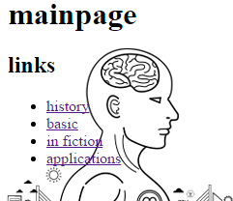

Source code:

